**Title of the abstract**

AuthorName AuthorSurname1, AuthorName AuthorSurname2

*1Affiliation (Institution, City, Country); 2Affiliation (Institution, City, Country)*

**Summary:** Please, write here a 1-2 line summary of your work, highlighting the novelty and impact.

**Introduction:** Please, write here the Introduction. This is some dummy text. Note that the total length of the abstract must not exceed two pages, including figures and references.

**Methods:** Please, write here the Methods section. This is some dummy text.

**Results:** Please, write here the Results section. This is some dummy text.

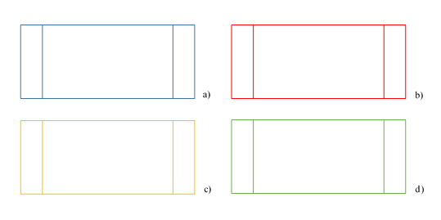

**Figures –** Description of figure 1a (a);Description of figure 1b (b);Description of figure 1c (c); Description of figure 1d (d).

**Discussion and Conclusions:** Please, write here the Discussion and Conclusions. This is some dummy text.

**References:** Please, list here your references using the following format:

[1] Morse P M, Feshbach H (1953), *Methods of Theoretical Physics, Part I*. New York, NY, USA: Mc-Graw Hill.

[2] Poynting J H (1885), “On the connexion between electric current and the electric and magnetic inductions in the surrounding field,” *Philos. Trans. R. Soc. Lond.*, vol. 176, pp. 277–306, doi: 10.1098/rstl.1885.0003.